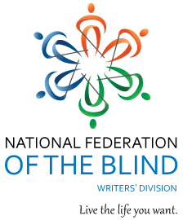

Writers! Readers!

Come Visit with Author

Barbara Hinske

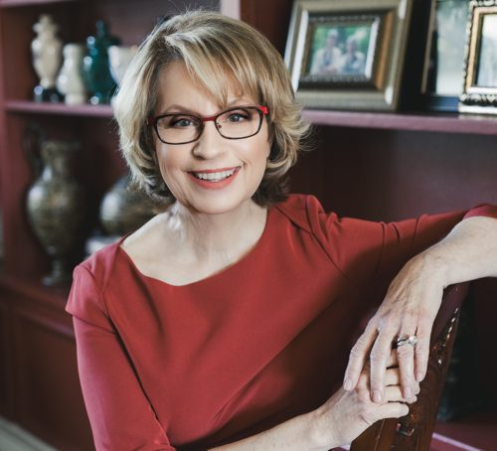

The National Federation of the Blind Writers’ Division Presents:

A conversation and Q&A with Barbara Hinske! The best-selling author of the Guiding Emily series (which features a blind protagonist) will join us as guest speaker.

[www.barbarahinske.com](http://www.barbarahinske.com)

[www.goodreads.com](https://www.goodreads.com/author/show/6798583.Barbara_Hinske)

Moderated by author

[Ann Chiappetta](https://www.annchiappetta.com/). All are welcome!

June 23rd - 7 PM ET,

6 PM CT, 4 PM MT

Zoom Link:

[Join NFB Writers’ Division Meeting](https://us06web.zoom.us/j/4056319755?pwd=ACADM2HTt2DEp7Sia9CA2vy1axmYlH.1&omn=87440036788)

Meeting ID: 405 631 9755

Passcode: aPNJW2

---

One tap mobile

+13462487799,,4056319755#,,,,*056024# US (Houston)

+16694449171,,4056319755#,,,,*056024# US

---

Dial by your location

• +1 346 248 7799 US (Houston)

• +1 669 444 9171 US

• +1 669 900 6833 US (San Jose)

• +1 719 359 4580 US

• +1 253 205 0468 US

• +1 253 215 8782 US (Tacoma)

• +1 408 638 0968 US (San Jose)

• +1 564 217 2000 US

• +1 646 876 9923 US (New York)

• +1 646 931 3860 US

• +1 689 278 1000 US

• +1 301 715 8592 US (Washington DC)

• +1 305 224 1968 US

• +1 309 205 3325 US

• +1 312 626 6799 US (Chicago)

• +1 360 209 5623 US

• +1 386 347 5053 US

• +1 507 473 4847 US

Meeting ID: 405 631 9755

Passcode: 056024

Find your local number:

<https://us06web.zoom.us/u/kchy6p7I5B>