Launch of the North America Accessibility Support Team

Every customer is important to us.
We’re passionate about providing the best possible experience for all our customers, including those with disabilities, to help them get the most out of Microsoft products. There are over 58 million people with disabilities in the US and 1 billion globally. Connecting customers with disabilities to experts that can guide them on accessibility features and help get the best from their devices and software is a top priority for Microsoft.
For the last several months, Microsoft Customer Service and Support has been piloting a new support offering that provides a tailored experience for people with disabilities and customers using our accessibility features.
Starting February 1st 2013, this experience is now available throughout North America, providing support specialists trained on accessibility and disability via telephone and email. Even though customer feedback has been overwhelmingly positive during the pilot, we know we still have a lot to learn. After a support interaction, customers will be asked to complete a short survey providing us with additional and ongoing feedback on how we can continue to improve this support environment.
Thank you for helping us to make this the best customer service and support experience, for all our customers.

Customer Partner Experience Team
Microsoft, Redmond, US

Q&A
Where is this available?
The Support Desk for People with Disabilities and/or Assistive Technologies is available in North America from 5am to 9pm PST during the week, and 6am to 3pm on the weekends. English Language only.
Will it be rolling out in my market and in my language?
We’re passionate about supporting all our customers around the globe and being able to provide the same level of guidance. We will be rolling out Support Desks for People with Disabilities and/or Assistive Technologies over the next year. More information on these areas will be available as they near launch.
Will you support 3rd Party Assistive Technologies?
While our goal is to help all customers be successful with their software and devices, support on 3rd party technologies will continue to come from those partners directly. Microsoft will help you with those connections whenever possible.
Will this remain as a free service?
Currently there is no charge to use the accessibility service although this is subject to change. All support services are aligned to current product and service warranty terms and pricing.
Are you launching chat support?
Yes! We are. Chat is an important communication mechanism for support. Chat will be rolling out in the next few months.
If I’ve got feedback, what do I do with it?
Ongoing feedback is the key to improving this experience for people with disabilities over time! After a support call or email, Microsoft will contact you with a short survey to capture your feedback; allowing us to continue learning and growing this support environment. In addition, customers can provide feedback at any time by completing this survey.

For more information:
Website: http://support.microsoft.com/contactus/
Contact: Senior Director, Accessibility Customer Experience, Customer Partner Experience Team
Jenny Lay-Flurrie, jennylf@microsoft.com

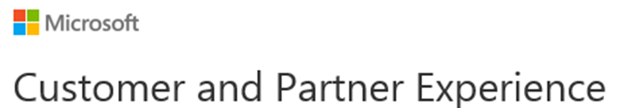
With 90,000 employees in over 190 countries supporting and developing varied products and services for our customers and partners, Microsoft is focused on ensuring a high level of satisfaction among our customers and partners. It is a core component of our business. Our vision is to provide experiences for our customers and partners, across all of their interactions with Microsoft, that they value and recognize, and enable them to realize their full potential
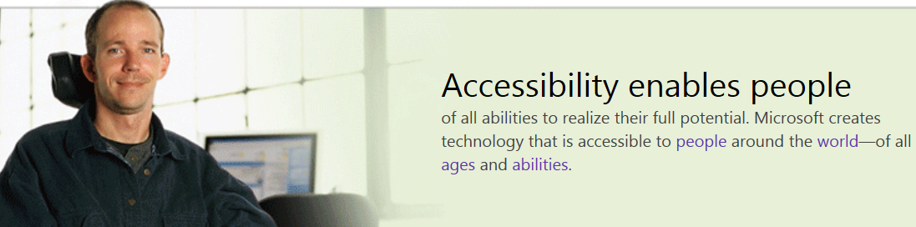

Accessibility Support Channel
In an effort to improve support to customers with disabilities, Microsoft has launched an Accessibility Channel to English speaking customers in North America. This channel is dedicated to assisting customers with the Accessibility Features of Windows and Office products. Customer feedback regarding this new channel has been phenomenal so far and has exceeded expectations. Our commitment to incorporating feedback from our customers with disabilities will allow Microsoft to further improve this customer experience as it moves forward serving this valuable customer segment.

Details of the Experience
http://support.microsoft.com/contactus/
(Picture shows ‘Get Accessibility Support Link’ – Assistance to customers with disabilities or looking for support with assistive technology)
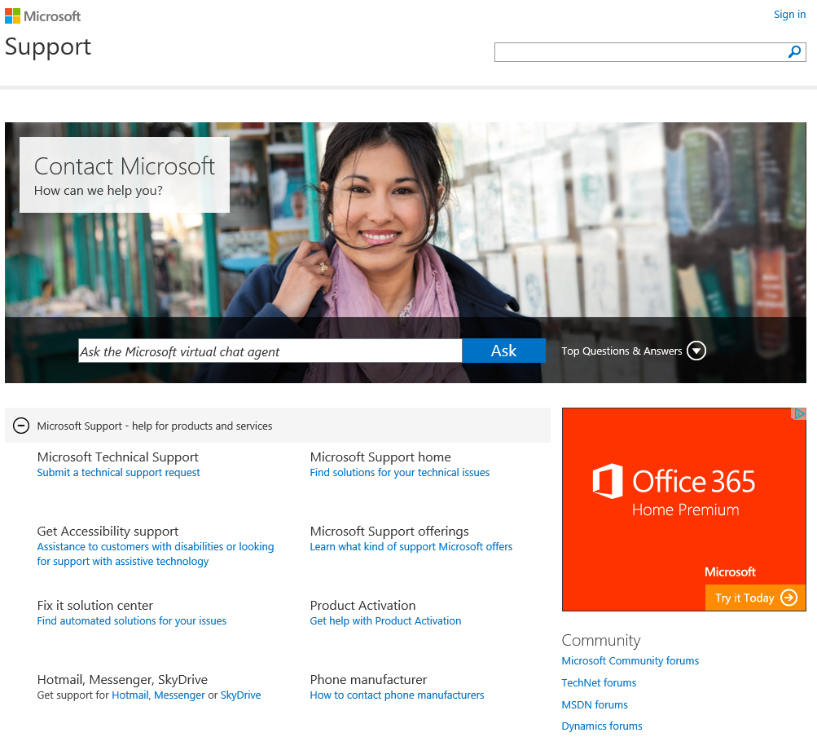

Contact Information
Direct Telephone Line: 1-800-936-5900
TTY: 1-800-892-5234
Weekdays: 5 A.M. - 9 P.M. (Pacific Time)
Weekends: 6 A.M. - 3 P.M. (Pacific Time)
Email Support: https://enable.microsoft.com/eform.aspx?productKey=enablefeedback&ct=eformts

