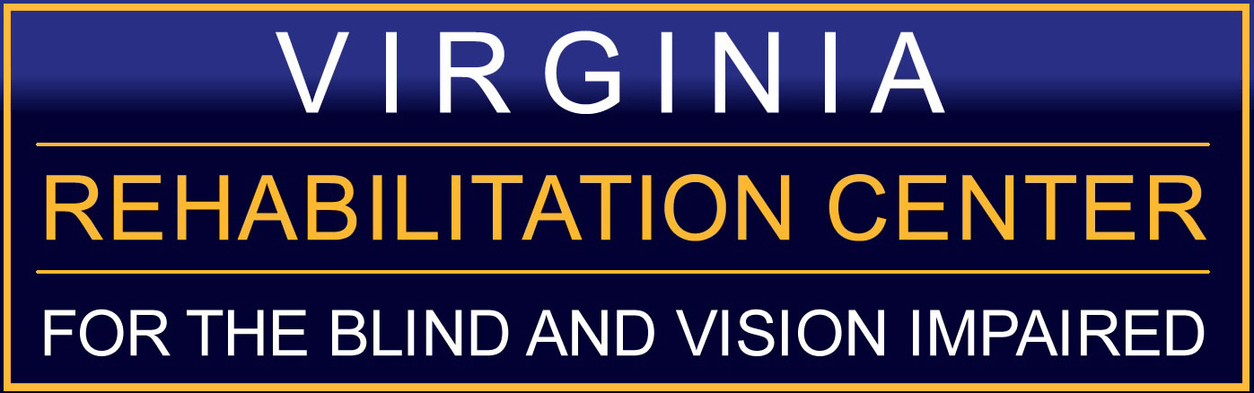
Seeking: Blind Mentors for 2017 LIFE Program
Are you ready to be an agent of change with the blind and vision impaired youth of Virginia?

The Virginia Rehabilitation Center for the Blind and Vision Impaired (VRCBVI) is seeking three blind college students or young professionals to be mentors for our 2017 Learning Independence, Feeling Empowered (LIFE) Program. Mentors will work alongside our instructional staff in areas which may include (but are not limited to): Braille, Cooking Skills, Access Technology, and College 101, as well as during after-hours confidence building activities. If you are enthusiastic about giving back to the next generation of blind and vision impaired youth and you want to have fun while working, then being a mentor in the 2017 LIFE Program is the place for you. We highly encourage mentors to be available June 12 through August 11, 2017. The 2017 LIFE Program will take place on the campus of VRCBVI in Richmond, Virginia.

LIFE is a five week residential summer program for high school-aged blind and vision impaired youth who want to learn the skills of blindness, participate in a college preparation or career exploration program, develop a positive attitude about blindness, and have fun while getting to know their blind peers.

Ideally mentoring candidates will:
- Possess excellent blindness skills specifically the ability to travel independently using a long white cane or dog guide while communicating with and monitoring a group of high school age students
- Be available from June 12, 2017 to August 11, 2017
- Be able to work 40 hours a week, including evenings and weekends
- Be able to communicate effectively with co-workers and supervisor
- Possess maturity, patience, and the ability to work as part of a team
- Enjoy teaching and have an enthusiastic sense of adventure
- Reside in the dorm apartments on the VRCBVI campus
- Pass a background check

Rate of pay: $10.00 an hour plus room and board

To learn more or to apply, please contact Greg Chittum by email at greg.chittum@dbvi.virginia.gov , by phone at (804) 371-3204, or by mail at 401 Azalea Avenue, Richmond, VA 23227.

To apply please provide the following five items:
- 1. Print copy of Commonwealth of Virginia Application for Employment by going to https://virginiajobs.peopleadmin.com/ to login or create an account, then proceed to “Click here https://virginiajobs.peopleadmin.com/postings/9275 if you want to create and save your application but not apply to a job.” After completing your application, go to print view where you can email the application or send a hard copy
- Cover Letter
- Resume
- Three professional references
- 500 word essay explaining why you would be the best candidate for the position and the role mentoring has played in your success

All applications must be complete and received by not later than April 14, 2017.

