NATIONAL FEDERATION OF THE BLIND
JERNIGAN INSTITUTE

THE BLIND AND VISUALLY IMPAIRED VOTER’S GUIDE

The Help America Vote Act

The Help America Vote Act (HAVA) was signed into law on October 29, 2002, to address the problems that occurred during the 2000 presidential election. One of the goals of HAVA is to provide all American voters, including those who are blind or visually impaired, with the opportunity to vote both privately and independently. Therefore, HAVA requires that by January 1, 2006, all voting jurisdictions must provide at least one accessible voting machine per polling place and that any voting machines purchased with federal funds provided under HAVA on or after January 1, 2007, must be accessible.

Why Blind Americans Should Vote

“Should things go wrong at any time, the people will set them to rights by the peaceable exercise of their elective rights.” Thomas Jefferson.

The right of blind Americans to vote is guaranteed by the United States Constitution. It is a right that many American citizens have demonstrated for, fought for, and died for so that present and future generations can continue to exercise their right to vote. Therefore, every blind or visually impaired citizen who is of voting age has a responsibility to exercise the right to vote.

Voting in any election, local or national, provides blind and visually impaired citizens with the opportunity to voice their opinion about elected leaders and policies and to help shape the future by electing candidates who share their views. Elected officials make decisions and pass legislation that establish the maximum income a blind person can earn while still receiving social security disability benefits, the minimum wage rate paid to blind workers in sheltered workshops, and the health benefits blind citizens receive under Medicare and Medicaid. Consequently, voting for candidates who share their views on these issues is one of the most effective ways that blind and visually impaired citizens can influence policy and legislation addressing these issues.

When a citizen does not vote, they are giving away their right to influence our government and, as a result, government by the will of the majority is replaced with government by the will of the minority. During the presidential elections of 2000 and 2004, a bare majority of 51 percent and 55 percent, respectively, of voting age Americans cast ballots. However, during the mid-term elections of 2002 and 2006, only 37 percent and 41 percent, respectively, of the voting age population voted. It is vital that blind and visually impaired Americans of voting age exercise their right to vote so that government by the will of the majority is assured.

A survey conducted by the National Federation of the Blind Jernigan Institute following the November 4, 2008 presidential election indicates that blind Americans are exercising their right to vote. Ninety-four percent of the 566 blind and visually impaired Americans of voting age who were surveyed were registered to vote and ninety-six percent of these registered voters actually voted in the November 2008 election.

Register to Vote

In order to exercise the right to vote, a blind or visually impaired citizen must first register with their state or district board of elections. To register, an individual must be a United States citizen, a resident of the state or district in which they are registering, and at least eighteen years old. Many states have additional requirements that must also be met. Registration forms can be obtained from your state, district or local board of elections; libraries; government offices; as well as on the Internet. Registering only takes a few minutes, so be sure to exercise your right and responsibility as a citizen by registering to vote and voting!

Resources

Your state, district, or local board of elections has voter registration forms and information about polling place locations and times, identification requirements, voting procedures, and voting machines. A nonpartisan organization, such as the League of Women Voters, can provide factual information about candidates, as well as tips on how to be politically effective. If a properly functioning accessible voting machine is not available at your polling place for a federal election, file a complaint with your state board of elections.

Make Your Voice Heard

The United States Constitution guarantees the right of all blind and visually impaired citizens to vote and the exercise of this right is vital to the function of our democratic form of government. With the passage of HAVA, it is now possible for blind and visually impaired citizens to exercise their right to vote both privately and independently. Making your voice heard through voting is imperative because state and federal elected officials implement policies and pass legislation that directly affect our lives as blind or visually impaired people. Make your voice heard - register to vote and exercise your right and responsibility to vote!

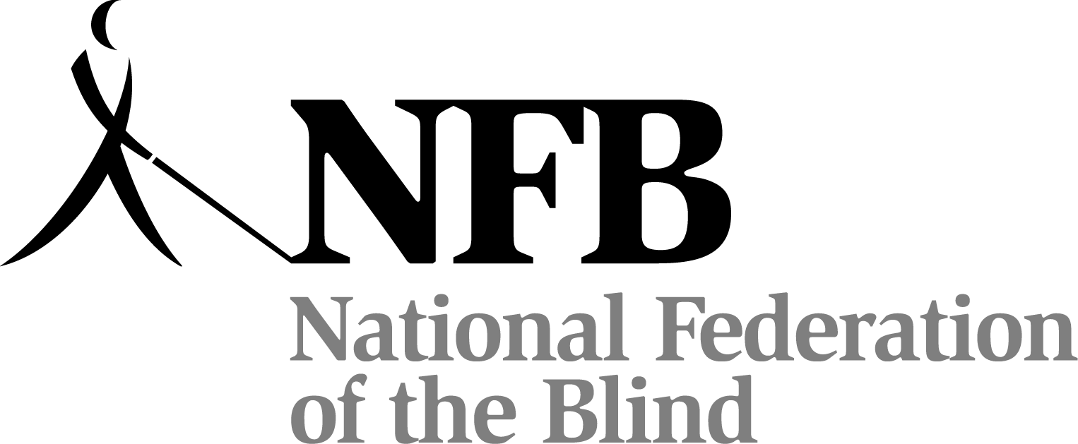

National Federation of the Blind
Jernigan Institute
1800 Johnson Street
Baltimore, Maryland 21230
(410) 659-9314
www.nfb.org
LBT34P

LBT34P

