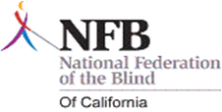
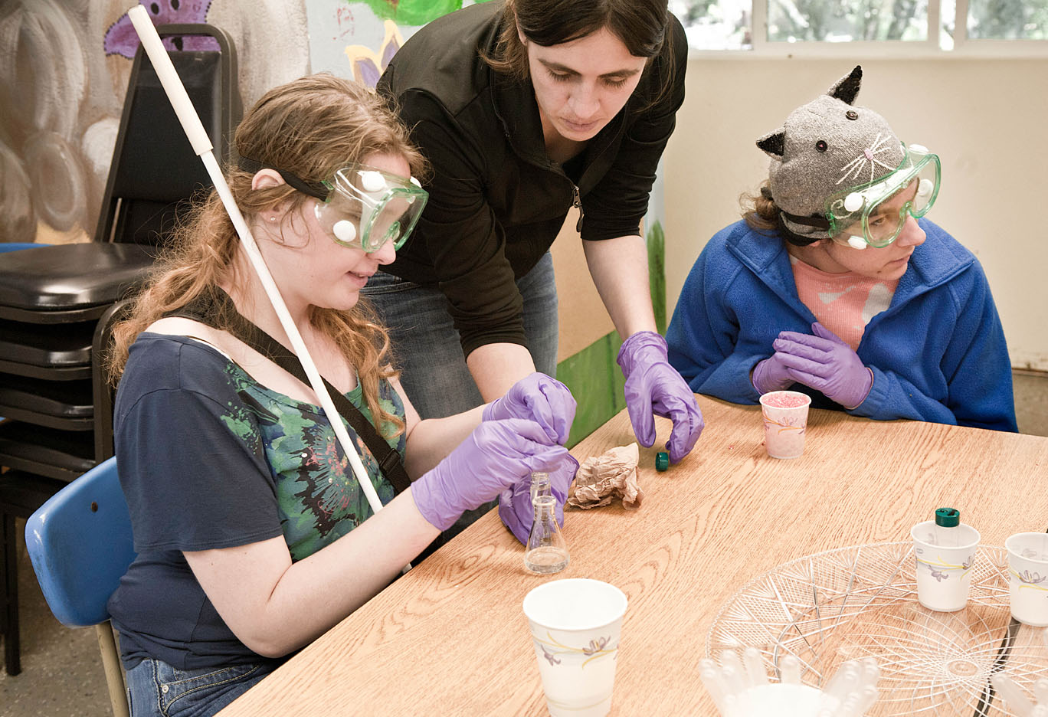

Breaking down Barriers

Come join the California Association of Blind Students (CABS) for a day of fun and learning. Activities will include:
- Hear from blind students/professionals who have been successful in science related fields
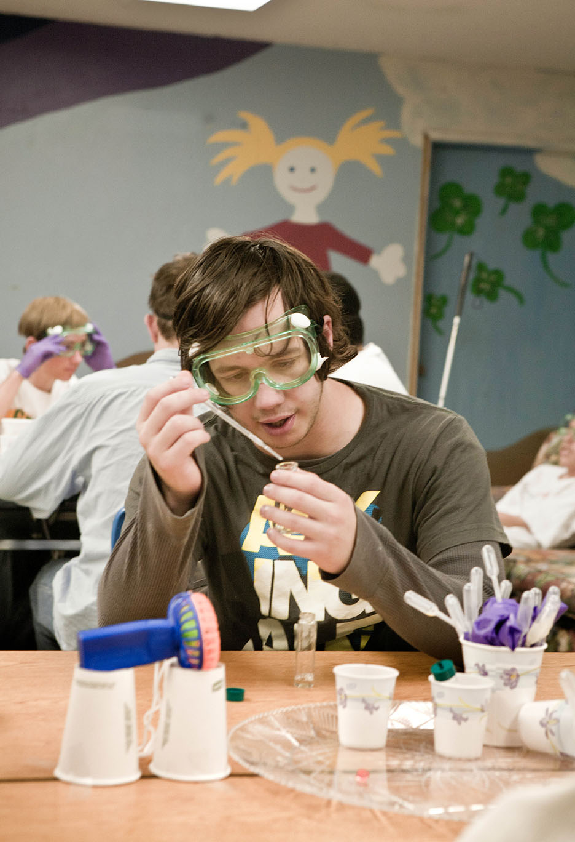
- Be empowered to gain the skills and confidence which will help you achieve success in school and work
- Learn about the technology which is breaking new ground in accessibility
- Get tips and techniques on advocating for the things you need
- Mix and mingle with successful blind people

When: September 21, 10:00 AM to 5:00 PM

Where: Sacramento State University
6000 J Street
Student Union, Orchard Suite
Sacramento, CA 95819

For more information or to register, please contact:
Angela Fowler,
530-902-0987
fowlers@syix.com
Or visit: http://www.nfbcal.org/cabs

