Learning Ally Audiobook Manager User Guide

Introduction 3
What is Learning Ally Audiobook Manager? 3
System requirements 3
How the BookShelf works 3
Searching and ordering books 5
Step 1: Search for books: 5
Step 2: Order books: 5
Learning Ally Audiobook Manager 8
What is Learning Ally Audiobook Manager? 8
Install the Learning Ally Audiobook Manager 10
Load the Learning Ally Audiobook Manager 13
First time installing? 13
Returning Users 13
Select player 14
Select books 15
Sync books to player 16
Download a book and sync to player 16
Player-specific syncing instructions 17
DAISY Hardware Player 17
DAISY Software/Learning Ally ReadHear 17
Learning Ally Audio App for iOS* 18
Windows Media Player or Windows Media MP3 player 18
Syncing files directly to your computer 18
Play books 19
Add a player 20
Configure Settings 22
Change the location of where my Downloads are stored 22
Customize my Internet Settings/Proxy Server 22
Manage Players 22
Advanced Settings 23

Introduction

Welcome to the Learning Ally Audiobook Manager User Guide. This User Guide is designed to help you through your experience in downloading and playing a Learning Ally book.

What is Learning Ally Audiobook Manager?
The Learning Ally Audiobook Manager is a program you run on your computer to download and sync your Learning Ally books to any Learning Ally authorized player, whether software or hardware, DAISY or Windows Media.

System requirements
- Windows XP, Vista, Windows 7
- Internet Explorer 7 or higher
- Firefox 3 or higher

How the BookShelf works
The BookShelf can be summarized in four easy steps:
- Search for your book
- Add your book to your BookShelf
- Download the book to your player
- Read!
You can search for books in the book catalog. From the Search Results page, you'll read a button labeled "Add to BookShelf".

Select "Add to BookShelf" button to order your book in a downloadable format.

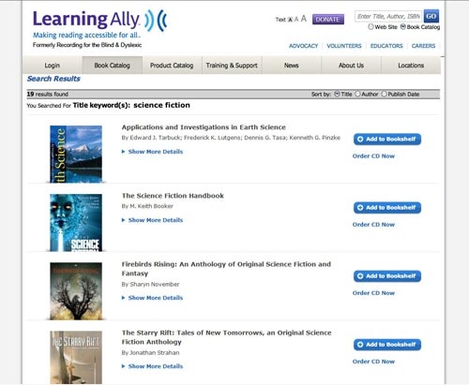
The BookShelf displays all titles you have added to your personal library. You can view the book details or remove a book from your account.
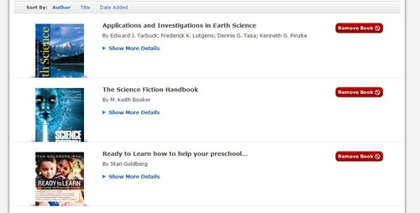
In order to download books and sync them to your playback devices, you will need to download and install the Learning Ally Audiobook Manager which is available via your online member account.

Searching and ordering books
Learning Ally has an extensive searchable book catalog. You can search by:
- Title
- Author

ISBN1: Search for books:
- Log in to your Learning Ally online account.
- Go to the Book Catalog.
- Search for your book by title, author, or keyword (for a more detailed search, select "Advanced Search").
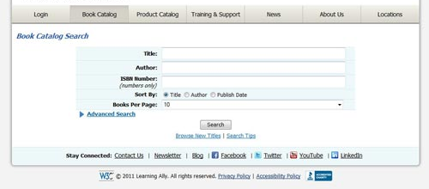

Step 2: Order books:
Once you have located your book in the book catalog:
- Select the "Add to Bookshelf" button to order downloadable books.
- Select "Order CD" for DAISY compact discs (if you choose the CD option, you will be directed to the checkout process).
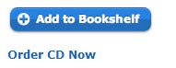
Your selected title will be ordered or added to your BookShelf.
Once you have added the books to your BookShelf, you will need to download and sync your books. Select the "Download & Listen" button to run the Learning Ally Audiobook Manager.

If the Learning Ally Audiobook Manager is not installed, selecting this button will prompt you to install the program.
If the program doesn’t automatically install, you will see a new window with a manual installation link.
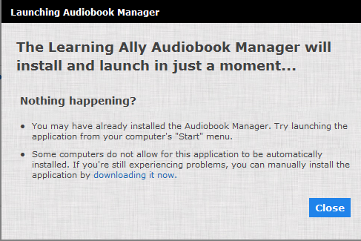
Selecting “downloading it now” will install the software.

Learning Ally Audiobook Manager

What is Learning Ally Audiobook Manager?
The Learning Ally Audiobook Manager is a program you run on your computer to download and sync your Learning Ally books to your Learning Ally authorized playback devices, whether software or hardware. The program knows what’s on your online BookShelf so you can easily download and sync titles to your favorite playback devices.
Let’s take a moment to get familiar with the interface:
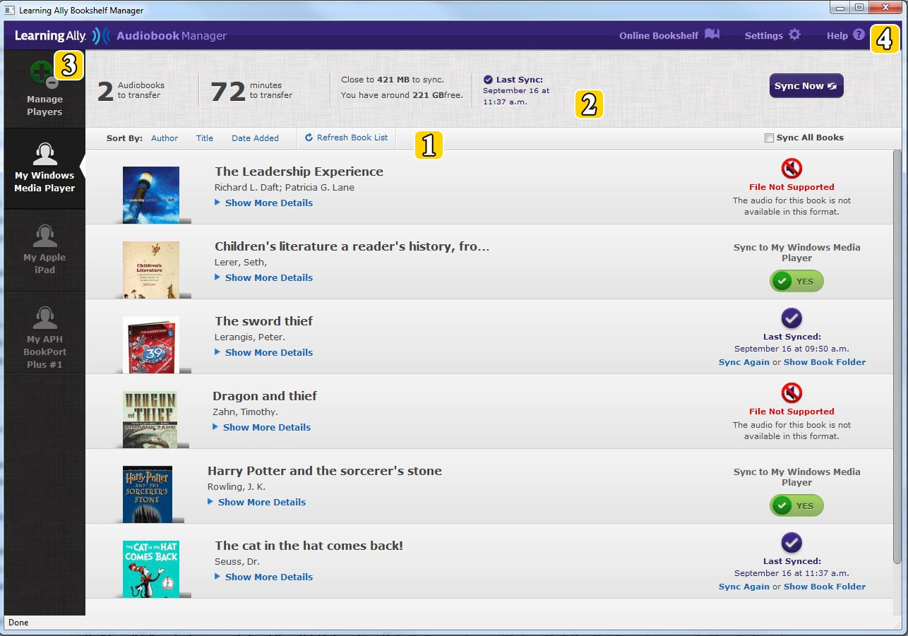
- My BookShelf:
Access this area any time with control + b. This area contains the books that have been placed on your online BookShelf. Using the up and down arrow keys, you can navigate between books and can also use the left and right arrows to navigate among options within a book such as syncing or viewing book details.
You can sort your list of books by Author, Title, and Date Added in the sort by pane, control + s.
When you order new books through your online BookShelf, press F5 to refresh your book listings. Please note that you cannot delete books from this program, but you can delete books from your account through your online BookShelf.
- Sync Summary pane:
You can access this portion of the screen with alt + S. The summary bar summarizes the properties of the books you select for transferring to your device, such as number of books selected, total number of minutes it will take to transfer, and file sizes. You can access these pieces of information individually with the up and down arrow keys.
- Manage Players pane:
Using control + P, you can access the area of the screen which is dedicated to organizing (and adding) your devices. If you have multiple devices, you can toggle between them with the arrow keys to sync books to each individual device in your collection.
- Top Menu pane:
When you press control + T, you can access the top menu. It includes the Online Bookshelf (your Learning Ally account), Settings and Help buttons. The Online BookShelf button will take you to your online account on LearningAlly.org. Here, you can search, add, and delete books in your BookShelf. In your Settings, you can modify the parameters you set during installation, organize your players, change your default player, and more. The Help button will launch the Learning Ally website to guide you through the program.

Install the Learning Ally Audiobook Manager

You will need to log in to your Learning Ally online account to access the Learning Ally Audiobook Manager. After logging in:
- Go to the "My Bookshelf" link. You can get there with the tab or arrow keys or through the links list function of your individual screen reader.
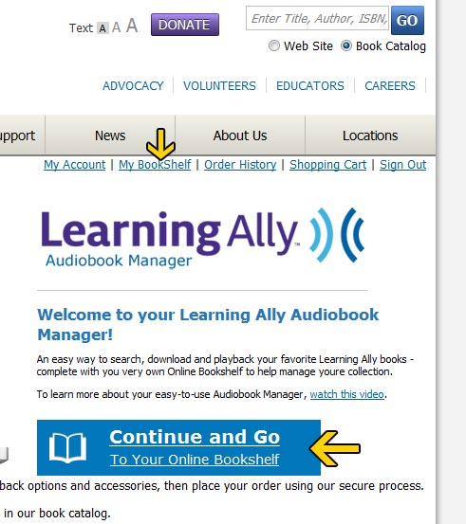
- Go to the "Download & Listen" link to get the Learning Ally Audiobook Manager software
- Select "Run."
In the event that the automatic installer doesn’t load, you will encounter a new window with a manual installation link. Download the installation file (about 10 MB in size) and follow the installation wizard prompts.
- Keep selecting "Next" until the Install wizard says "Finish".
- Learning Ally Audiobook Manager will launch and will present the Setup screens. You will need to complete the initial setup of the program by choosing your download path folder, proxy options, and adding a player.
- In the Setup Account window, you can change the file path of your download or simply select “Next Step” to accept the default settings. You can also adjust your Proxy settings. For typical users, we recommend leaving this to "No Proxy." Advanced users may want to select Auto-Detect or manually enter in proxy settings.
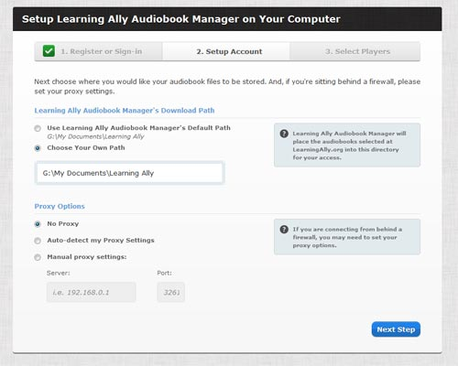
- Next, in the Select Players window, you will have to add a default device to the Learning Ally Audiobook Manager. You can choose to add additional playback devices after the software is completely installed. When you finish this step, the software will load.
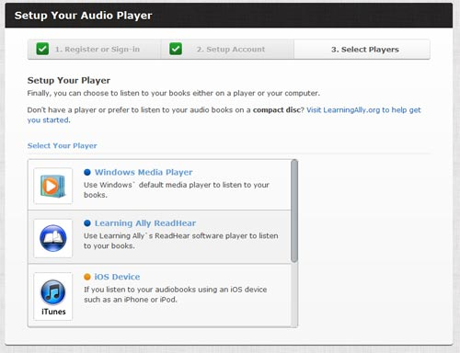
There are four basic types of playback options available:
- Windows Media Player
- Learning Ally ReadHear
- iOS Devices (iPhone, iPad, iPod touch)
- DAISY playback options

Load the Learning Ally Audiobook Manager
Just five steps and you’ll be on your way to playing your books!

- Start up and login
- Select player
- Select books
- Sync books to player
- Play books

First time installing?
If you are installing the Learning Ally Audiobook Manager for the first time, simply select the "Download & Listen" button located at the top of your BookShelf page, and follow these step-by-step instructions.
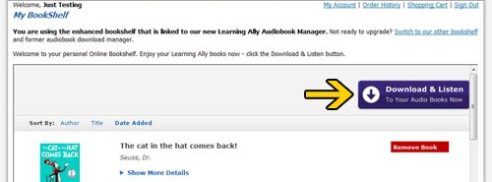

Returning Users
If you have previously downloaded and installed the Learning Ally Audiobook Manager, you can launch the application from your desktop shortcut or list of Program Files on your computer.
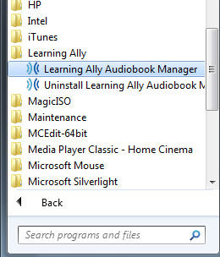

Select player
During installation, you selected a player to add to your Learning Ally Audiobook Manager; you can also add more players from a list of supported hardware and software after installation. The type of device that you have chosen will determine which book format the Learning Ally Audiobook Manager needs to download and sync.
When you are ready to download and sync your book, simply use the up and down arrows to select a player from the players pane in your Learning Ally Audiobook Manager. After selecting a player, you can then tab to choose which book(s) you would like to download and sync.
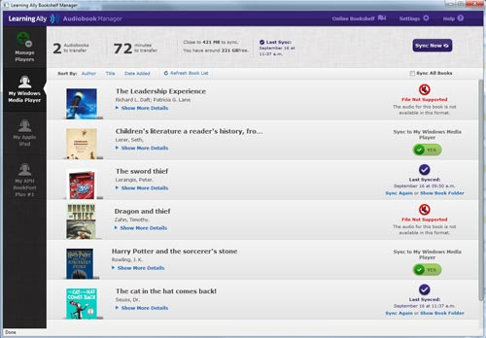

Select books
From your BookShelf, you can select your desired book by pressing the up or down arrow until you hear the book you want. Then press the right arrow to access the sync button for that book, and press enter. Then press alt + S to go to the sync summary pane, and select the sync now button with the up or down arrows followed by enter.
You can also choose to sync all books by checking the box in the sort by pane, (control plus S).
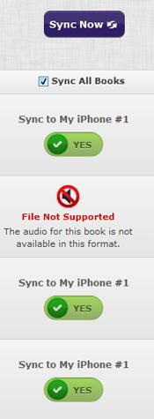
This will select all compatible books in your BookShelf to sync to your desired player, one at a time.
File Not Supported: Please note that some books are not supported by certain players. For example, DAISY-formatted compatible books may not be supported by Windows Media Player, and vice versa.

Sync books to player

Download a book and sync to player
- Select "Sync Now" in the sync summary pane to begin download process.

- The Learning Ally Audiobook Manager will validate your player. If there is an error, you will receive an error message .
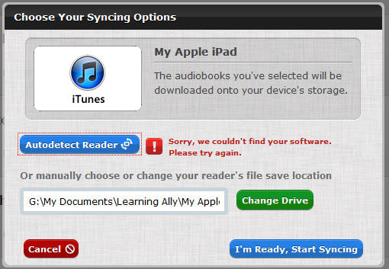
If this happens, you can either attach your player to the computer and select the “Autodetect Reader” button to try again, or you can just continue; your files will be downloaded to the location indicated. When your player is successfully detected, select the "I'm Ready, Start Syncing" button.
- The Learning Ally Audiobook Manager will announce the progress of your download.
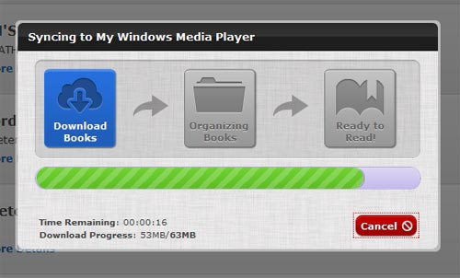
- You will be prompted with further instructions depending on the type of player you are using.

Player-specific syncing instructions

DAISY Hardware Player
- The Learning Ally Audiobook Manager will prompt you to connect your device.
- Connect your device.
- Manually choose or change your reader's file save location using the "Change Drive" button. If you use the Autodetect feature, make sure that the location is accurate before syncing to the device.
- Select "I'm ready to start syncing".

DAISY Software/Learning Ally ReadHear
- The Learning Ally Audiobook Manager confirms that the ReadHear software is installed on the computer. If you are using Learning Ally ReadHear by gh for PC, the Learning Ally Audiobook Manager will add the book to your software's library.
- Files will be downloaded to the default location. You can change with “Change Drive”.
- After download, you can open your books using your software’s “open book” command.
- If you don’t know where the books are, you can use the “show book folder” command.

Learning Ally Audio App for iOS*
Learn more about the Learning Ally Audio app
- The Learning Ally Audiobook Manager confirms that iTunes is installed on the computer.
- After download, you will be prompted to launch iTunes. Selecting the ”Launch iTunes” button will transfer the zip file of the book to the Learning Ally Audio App.
- Read instructions on transferring your book to your iPad, iPhone or iPod touch.
Download the guide in PDF format
Download the guide in Word format
* Purchase of Learning Ally Audio app ($19.99) is required in order to play Learning Ally audiobooks on iOS devices.

Windows Media Player or Windows Media MP3 player
Windows Media Player:
- The Learning Ally Audiobook Manager confirms that Windows Media Player version 10 or higher is installed on the computer and will add the book to your Windows Media Player Album section.
- The books will be stored in the default folder location you set up during installation.
- Once you have synced a book to the player, select the “Launch Windows Media Player” button to play your book in Windows Media Player.
- The license acquisition process will begin automatically the first time you try to play a book in Windows Media Player. A screen will pop up prompting you to get the license. You may need to provide your Learning Ally account login and password to do this.
Windows-based MP3 players: Syncing instructions for loading books to your MP3 player (read more about MP3 players that are compatible with Learning Ally audiobooks).

Syncing files directly to your computer
- From Settings, choose "Manage Files Yourself".
- Your files will be saved to the default location you indicated when you set up the manual transfer player. If you want to change that location now, select "Change Drive".
- Select "I'm ready to start syncing".

Play books
Once you have chosen a book and the sync is completed, the Learning Ally Audiobook Manager will instruct you on what to do next depending on your specified playback device. Player-specific syncing instructions.
Get help using your playback devices on LearningAlly.org.

Add a player
After you've installed the Learning Ally Audiobook Manager and set up a default player, you can add any number of additional players using the "Manage Players" button. Here's how to get started:
- Select "Manage Players" in the players pane by using the down arrow. This will show you a list of your current players and will give you access the Add a Player area.
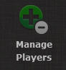
- Select the "Add a Player to Learning Ally Audiobook Manager" button.
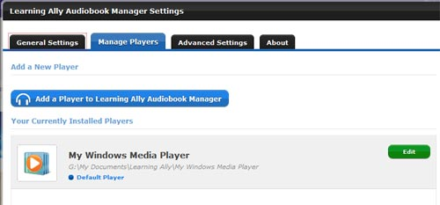
- Choose your selected type of device: Learning Ally ReadHear, Windows Media Player, iOS device or DAISY Player.
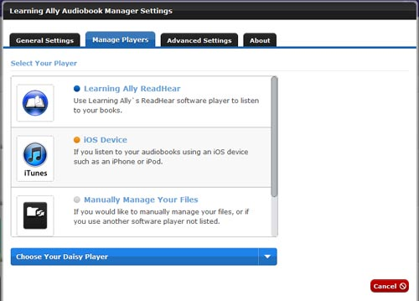
- If desired, assign a reader nickname to your device and choose a file path if different from default.
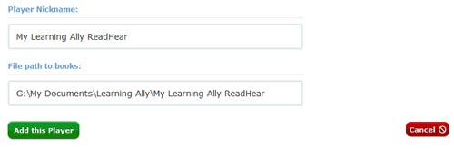
- Select "Add this Player"
You can also choose to manually manage your files. This option will allow the book files to be saved to your specified location on your computer.

Configure Settings

Change the location of where my Downloads are stored
By default, the Learning Ally downloads are stored in the following locations:
- For Windows XP: My Documents/Learning Ally
- For Windows Vista and 7: Documents/Learning Ally
You can change the location by selecting or creating a unique folder to store the downloads. Select the "Settings" button in the Learning Ally Audiobook Manager, and edit the "General Settings" tab. Note that if you aren’t brought to this tab by default, you can press control + tab to navigate to the general settings tab.
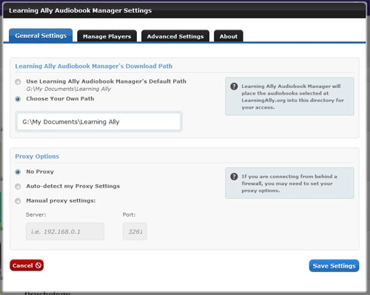

Customize my Internet Settings/Proxy Server
If you use a proxy to connect to the Internet, you can configure that under the "General Settings" tab. Try the “Auto-detect” option first. If this doesn’t work, try setting your proxy manually.

Manage Players
Once you have installed and set up the Learning Ally Audiobook Manager, a list of your selected devices will appear on the players pane. You can choose which player you wish to sync a book to and manage your players at any time. See the above section about “Add a player”.

Advanced Settings
The "Advanced Settings" tab gives you a few more options for managing your books. You can purge your cache of downloaded books, and view your syncing and downloading history.
