
Save Thousands on Low Vision Demo Products from Smart Assistive Technologies!

Contact Us at: 603-330-3533 or Info@SmartATI.com

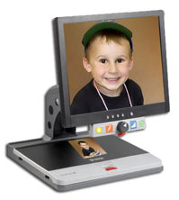
Topaz Demo Unit Price:
17” $1,000
19” $1,200
50% Off Demo Models w/2 year extended warranty option!
Retail Price - $2,495.00 for 17” and $2,799.00 for 19”

The TOPAZ is your personal low vision center - powerful yet so easy to use - and an invaluable reading aid for those with a degree of vision loss.
- LCD monitor - Adjustable height and tilt for your viewing comfort
- Unique Freeze Frame feature
- Magnification dial - Adjust magnification from 3 times up to 82 times the actual size
- Control Panel - Simple, accessible controls for color selection and brightness
- Position Locator Beam - Easily guides you to exact document placement
- Reading Table - Generous size, with fingertip control and wide side-to-side motion

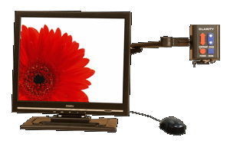
Onyx DeskSet XL Demo Unit Price: 17” $1,200
50% Off Demo Model
Retail Price - $2,595.00 for 17”

Portable Magnification! Fits in any classroom, business, or home and move from one viewing situation to the next as quickly as you do. Plug into any standard wall plug; and it is ready to deliver crisp, clear magnification. The ONYX Deskset XL 17, with a 17" monitor, magnifies from 1x up to 64x. The ONYX Deskset XL camera and monitor mounting system are unique:
- The low vision camera is mounted on an arm that telescopes to lift the camera so that it is easy to focus on the whiteboard or the teacher in the front of the room
- The mounting arm has three axes. It swings in a 350 degree arc, and the camera rotates 350 degrees on the end of the arm to look in any direction.
- The camera can be focused on the desktop directly in front of the user or moved to the side of the monitor to increase the work area
- The monitor can be raised, lowered, or tilted to the most comfortable position

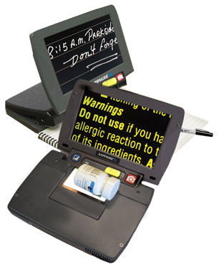
Sapphire Demo Unit Price: $595.00
Retail Price - $1,695.00

A superior independent living aid to a clumsy magnifying glass
A sliding magnification bar makes it easy to adjust and readjust the SAPPHIRE pocket magnifier to the level you need for any size type in any situation. Easily go from reading the larger type on a contract or bill to the fine print - and back again. There's no frustrating distortion and readjusting when you move the SAPPHIRE like there is with a magnifying glass.

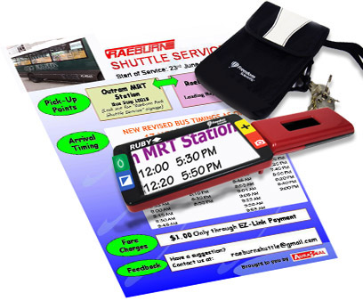
Ruby Demo Unit Price: $300.00
Retail Price - $645.00

Small portable handheld magnifier
For the many people who need help reading text and seeing details because of low vision, traditional magnifying glasses work only up to a point. The RUBY video magnifier takes handheld magnification to the next level and beyond. The RUBY’s 4.3-inch, full color, high brightness video screen makes it outstanding for reading bills, letters, checks, and receipts. It is so small and unobtrusive that it easily slips into a pocket or purse as the perfect traveling companion for visiting the grocery store, the pharmacy, the bank, the library, bookstore, restaurant, or anywhere else.

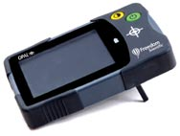
Opal Video Magnifier Demo Unit Price: $200.00 only 2 demo models left!
This model has been discontinued so get it while you can!
OPAL video magnifier is small and very portable. It weighs only a few ounces and can fit into a large pocket like on cargo pants. It is simple to use two buttons, one to turn it on and off and one to choose the contrast you want. On the side is a slide to control the magnification. It is used by setting the magnifier right on the page and sliding it along. The camera is on the right hand side of the magnifier and the screen center and left side. The viewing screen is large for the type of magnifier. The case is also quite rugged with rubber on the corners.
There are fold down legs under the right hand side that, when folded down, give you room to use a pen to write checks, sign papers etc. As far as portable video magnifiers go, it is a great value. It comes with a110V charger and a carrying case.
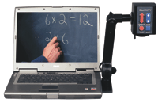
Clarity PC Mate Demo Unit Price: $1200.00
Retail Price – over $2495.00 The PCMate comes with the Clarity Capture software which allows you to capture an image and use a split screen without the need for any accessories such as a battery or separate monitor. It is extremely portable.
If you need magnification on the go while using your laptop then the PCMate is for you. Whether you are a student or on a business trip, the PCMate gives you the portability and the ease of connectivity allows you to view whatever you need at a moment’s notice.

Minimum computer requirements:
Windows Vista, XP (Windows 7 compatibility upgrade is $235.00 extra)
USB-2.0
1GHz processor
512 MB RAM
64 MB Video card

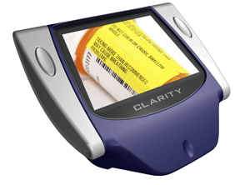
Clarity Junior Demo Unit Price: $200.00 Retail Price $645.00 Savings!
The Junior offers:
- 4" LCD screen
- 11 ounces, 5¼ x 4¾ x 1½ inches
- 3 hour battery life
- 3-9X magnification
- Reading and writing ability
- Standard wall charger with optional car charger
- Video output to use with larger screen
- Contrast and Mode
- Color, Black and White, Inverse, and Color Select mode
- Carry bag for portability
The Junior is backed by a lifetime warranty by the manufacturer. This product is individually handcrafted in the USA.

Pocket Eye Q Demo Unit Price: $195.00
Retail Price $495.00
The Eye-Q is slim and sleek, compact and lightweight, truly portable with high magnification on a pocket-sized machine. Brightness is controlled automatically and instantly with no extra button needed. The side camera and foldable legs make a perfect Writing Mode for both right and left hand.
- Very long Depth Of Field
- Wide Viewing Angle
- High resolution full color anti-glare 16:9 TFT-LCD wide screen
- Black on White and reverse display images
- Freeze Frame
- Continuous focusing
- Easily connects to any television for increased magnification

9 Brand New in Box, Keys U See Low Vision keyboards available only $20 Each – compare at retail for $40.

3- White on Black
4 – yellow on Black
2 – Black on White

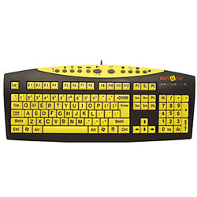

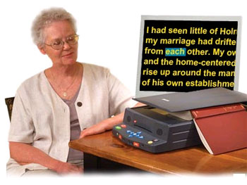
Sara Scan & Read Appliance only $1,400!
Retails for $2,795.00

Pac Mate Omni QX400 with 40 Cell Braille Display. Retails for $4,895.00. Demo Price Only $2,495.

Pac Mate BX400 with 20 Cell Braille Display (not an Omni). Retails for $2,895.00. Demo Price Only $1,500

