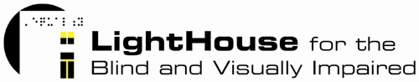

Development Intern

The LightHouse is seeking an ambitious, talented individual to join our organization as our Development Intern. Below are the accountabilities and assigned projects one can expect from this position:
- Assist with data entry into Raiser’s Edge, the organization’s donor database, adhering to strictest confidentiality requirements
- Gathering mailing list data across all agency programs and locations and complete data entry to compile and manage mailing lists
- Creating organizational systems to manage cross-departmental communications and work flow
- Writing, editing and coordinating newsletter, social media, web and blog content
- Gathering and disseminating client stories across multiple channels
- Assist with volunteer training preparation and other volunteer program needs
- Compile information for donors and other stakeholders
- Assist with meeting set-up and breakdown
- Assist with filing, copying, faxing, mailings and other department administrative functions as needed

The LightHouse is the largest organization in Northern California serving the blind community. We offer programs that range from teaching blind youth critical technology skills to excel in school and work to training seniors new to vision loss in alternative techniques for daily living. Our San Francisco headquarters is our operations hub that manages the delivery of all San Francisco-based on-site programs, a retail store selling adaptive aids, an accessible summer camp and retreat in Napa, a manufacturing division in Oakland and two satellite offices in Marin and the North Coast. As a part of our team, the LightHouse Development Intern will receive transferable on-the-job, up-to-the minute non-profit experience at one of the Bay Area’s longest-standing non-profit institutions.

This is an unpaid internship. Interested candidates should have the capability to devote at minimum a semester or the equivalent to this role.

Those interested should contact:
Jennifer Yeagley
Director of Development
(415) 694-7333
jyeagley@lighthouse-sf.org

