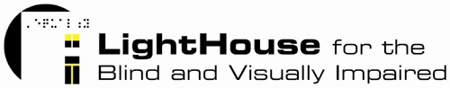

Multi-Media Intern

The LightHouse is seeking an ambitious, talented individual to join our organization as our Multi-Media Intern. Below are the accountabilities and assigned projects one can expect from this position:

- Video, audio and photo capture and editing
- Creating and editing content for print and on-line publications
- Capturing client stories in writing, video and audio
- Editing video and audio segments to produce useable features across various distribution channels
- Creating a system for organizing and document existing video and audio footage
- Compiling information on and keeping up to date a LightHouse media catalogue
- Updating and uploading web-site copy and other content
- Creating and posting content on LightHouse blog, Facebook, Twitter, YouTube and Flickr
- Researching media outlets and current contact information for LightHouse media pipeline (traditional and non-traditional media).

The LightHouse is the largest organization in Northern California serving the blind community. We offer programs that range from teaching blind youth critical technology skills to excel in school and work to training seniors new to vision loss in alternative techniques for daily living. Our San Francisco headquarters is our operations hub that manages the delivery of all San Francisco-based on-site programs, a retail store selling adaptive aids, an accessible summer camp and retreat in Napa, a manufacturing division in Oakland and two satellite offices in Marin and the North Coast. As a part of our team, the LightHouse Multi-Media Intern will receive transferable on-the-job, up-to-the minute non-profit experience at one of the Bay Area’s longest-standing non-profit institutions.

This is an unpaid internship. Interested candidates should have the capability to devote at minimum a semester or the equivalent to this role.

Those interested should contact:
Jennifer Yeagley
Director of Development
(415) 694-7333
jyeagley@lighthouse-sf.org

