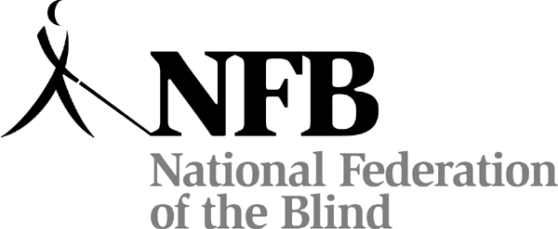

For Blind High School Seniors through Grad School Students

The $12,000

Kenneth Jernigan Scholarship
and
1 Scholarship for $10,000
2 Scholarships for $7,000 each
4 Scholarships for $5,000 each
22 Scholarships for $3,000 each
PLUS other gifts to scholarship winners!

ARE YOU A LEGALLY BLIND STUDENT?
Go to:
www.nfb.org/scholarships
for the
NATIONAL FEDERATION OF THE BLIND
2010 SCHOLARSHIP PROGRAM

To Apply: Read the rules and the Submission Checklist, complete the official 2010 Scholarship Application Form online or submit a print form, send all required documents before the deadline, and complete one telephone interview with our representative.

Questions to: NFB Scholarship Committee Chairman, Mr. Anil Lewis.
Office: (410) 659 -9314; E-mail: Scholarships@nfb.org

Deadline: All documentation must be received or postmarked
by March 31, 2010.

